Icepi Zero Testing Guide

Option A (Testing via laptop)
A/ Installing needed tools (One time setup)
1. Download openFPGALoader from https://github.com/trabucayre/openFPGALoader/releases/tag/v0.13.1 and add it to the PATH.
2. Download this bitsteam file: https://hc-cdn.hel1.your-objectstorage.com/s/v3/166d0dd2593e05acd9747d1eceeedd6a2dc0cd1f_icepi-zero-fire-v-test.bit
B/ Testing (Once per board)
1. Plug in a USB-C cable to the computer/testing equipement and to the USB-C port most on the left (Labeled Flash)
2. Open up the Terminal/Command promt and type “openFPGALoader -c ft231X –pins=7:3:5:6 openFPGALoader -c ft231X –pins=7:3:5:6 166d0dd2593e05acd9747d1eceeedd6a2dc0cd1f_icepi-zero-fire-v-test.bit” (The directory must contain the downloaded bitstream file)
3. Plug in a HDMI mini cable to the Icepi Zero’s HDMI port, and the other side to a monitor. If the PCB works it should show such a screen:
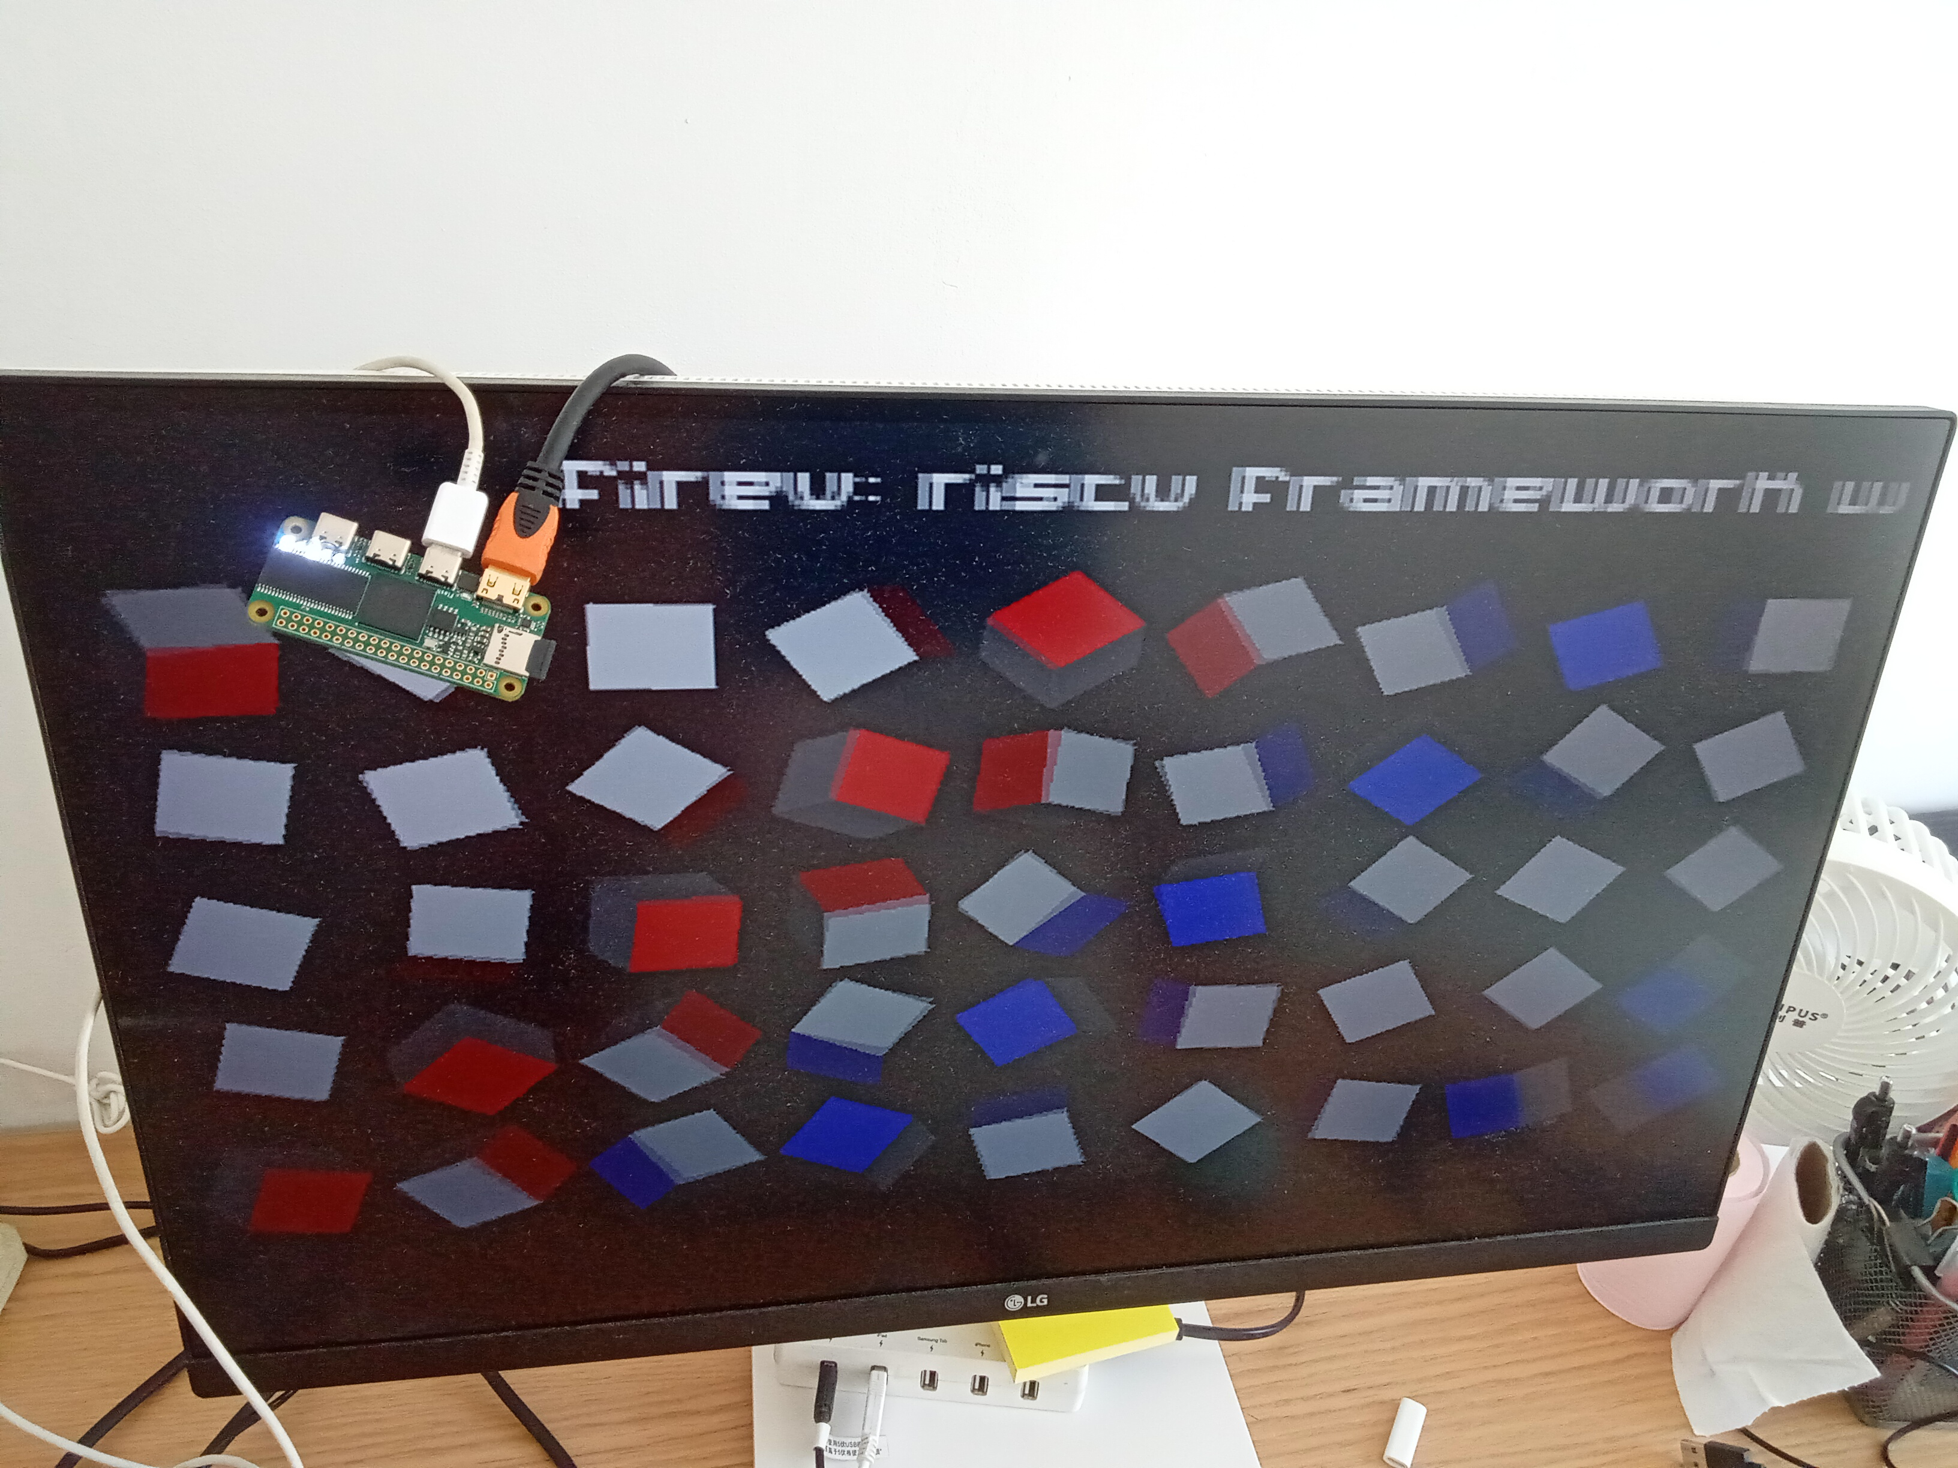

Option B (Flashing via JTAG test points)
A/ Setup:
1. Download this bitsteam file: https://hc-cdn.hel1.your-objectstorage.com/s/v3/166d0dd2593e05acd9747d1eceeedd6a2dc0cd1f_icepi-zero-fire-v-test.bit
B/ Testing (Once per board)
1. Flash on the bitstreams using JTAG on the following highligted pins:
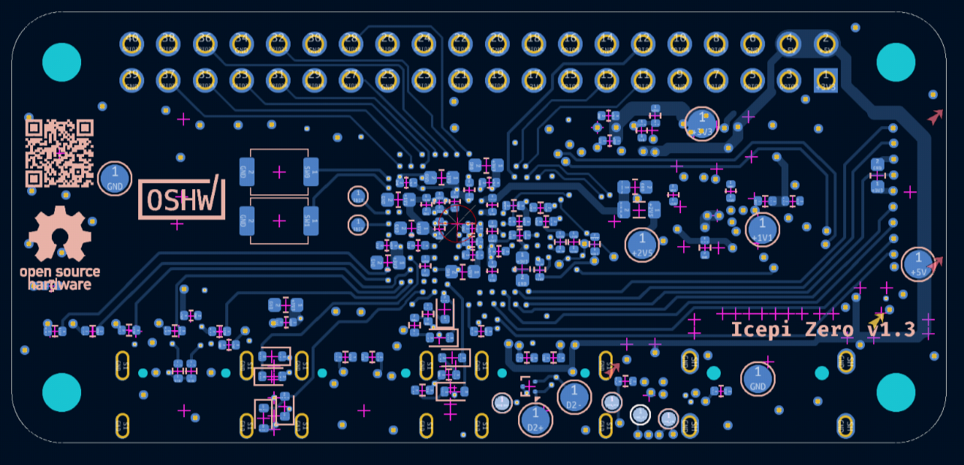
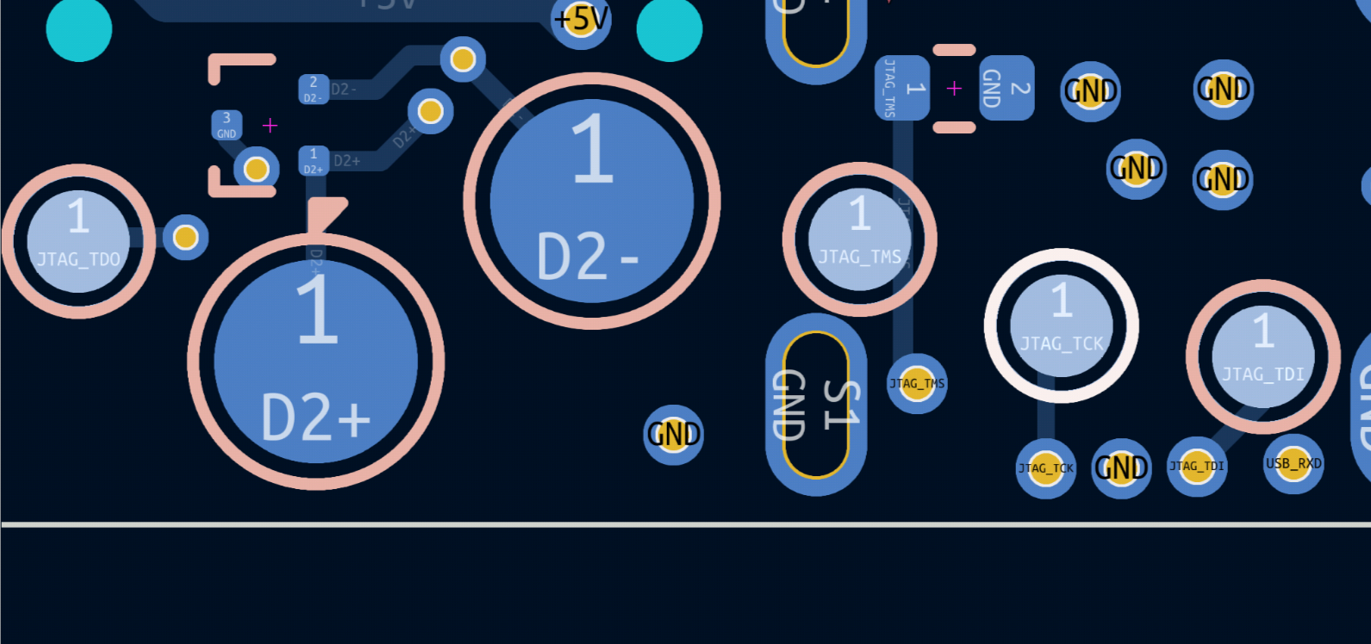
2. Plug in a HDMI mini cable to the Icepi Zero’s HDMI port, and the other side to a monitor. If the PCB works it should show such a screen:

